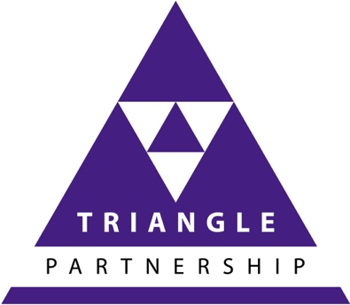
TA Tribe

TAOnline for trainers, coaches, consultants and managers

Booking Form
Name |  |  | Mobile  phone number:
Email
Address:
Address

TA Qualifications  Attendance at these workshops can be counted towards the requirements for international qualification as a Certified Transactional Analyst, for the International Centre for Developmental Transactional Analysis Certificate and Diploma, and for MSc Professional Development (DTA, DTA Coaching etc depending on your specialisation).  Contact us for more information about the full requirements and specialisation options.  Formal qualifications are optional - you are welcome to attend any modules to build your competence without seeking any form of accreditation. | WORKSHOPS
 | Date 2020 | Name of online workshop |  | Tick
 | 2 and 9  October | TAOnline 101
 | TBA | Cracking the Code
 | TBA | Rackets and Racket system
 | TBA | Changing your script
 | TBA | Discounting – Breaking the spell
 | TBA | Contracting for clarity
 | TBA | Power – Functional Ego States
 | TBA | What lies beneath – Structural Ego States
 | TBA | Psychological games – and how not to play
 | TBA | Organisational Structures and boundaries
 | TBA | Group dynamics - imagoes
 | TBA | Cycles of Development – where are you?
 | TBA | The Permission Wheel – how to thrive
 | TBA | Systemic Leadership
 | TBA | Group Process
 | TBA | Writing the CTA Written exam
Fees: One day workshops - £85 plus vat
TA101 Online (two days) - £150 plus vat
Timing: 9.30 am – 4.30 pm
Invoices are emailed post workshop

CONTACT: Lynda@trianglepartnership.com

