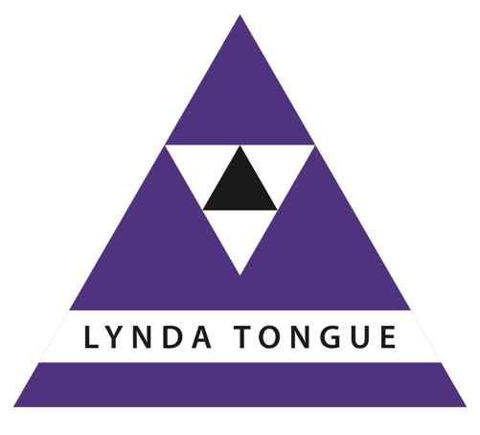
TA Tribe
Online Transactional Analysis Training and Supervision for organisational practitioners
Lynda Tongue (TSTA-org)

Tribe Advanced Practitioners (TAPs)

Workshop Programme 2020 – 21

Booking Form

Name

Address

Mobile phone number

Email address

Fees and Payment

TAPs Theory workshop – 6 hrs | £95 plus vat
TAPs Supervision workshop  – 6 hrs | £95 plus vat
Discount available | Book five workshops in advance and get the last one  at 50% discount  Book ten workshops in advance and get the last one free

Invoiced post workshop, bank transfer or Paypal options

TA training and tutorials
Attendance at these workshops can be counted towards the requirements for international qualification as a Certified Transactional Analyst, for the International Centre for Developmental Transactional Analysis Diploma, and for MSc Professional Development (DTA, DTA Coaching etc).

These formal qualification routes are optional - you are welcome to attend any modules to build your competence as a coach, trainer or manager without seeking any form of accreditation.

Contact

Lynda Tongue (TSTA-org)
www.ta-tribe.com/contact

Tribe Advanced Practitioners (TAPs) Workshop Programme

Date | Workshop | Tick
5 September 2020 | TA in the Workplace
6 September 2020 | TAPs Supervision workshop
24 October 2020 | Critiquing Research
25 October 2020 | TAPs Supervision workshop
21 November 2020 | Working with Change
22 November 2020 | TAPs Supervision workshop
12 December 2020 | Research Design
13 December 2020 | TAPs Supervision workshop
23 January 2021 | TA Culture and Reflective Practice
24 January 2021 | TAPs Supervision workshop
27 February 2021 | Enabling and Empowering Others
28 February 2021 | TAPs Supervision workshop
20 March 2021 | Leading Learning
21 March 2021 | TAPs Supervision workshop
17 April 2021 | Systemic Leadership
18 April 2021 | TAPs Supervision workshop
29 May 2021 | The Present-Centred Practitioner
30 May 2021 | TAPs Supervision workshop
11 June 2021 | SuperVision and the Meta Perspective
12 June 2021 | TAPs Supervision workshop

