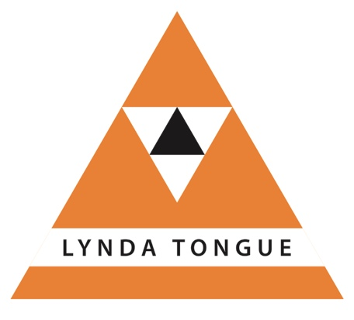
TA Tribe
…….TAOnline

Workshops and supervision
one-to-one, or in small groups

Booking form
Name
Email
Phone Number
Address
Time zone
Workshop Fees | Tribe - (3 hrs duration) £35 plus vat per workshop  TA 101 - £125 plus vat for 3 x 4 hr workshops
Online Workshop Programme 2019
Date | Title | Tick
4 January | Group process
1 February | Groups and stages of development
3 May | Making contact – match, move and grow!
7 June | Systemic leadership – organisational systems
5 July | Mind the gap – unconscious processes
6 September | All you ever needed to know about discounting …..
11 October | Identifying Personality Adaptations
8 November | Autonomy – no strings attached!
Register your interest | TA 101 online – part 1 (4 hours)
 | TA 101 online – part 2 (4 hours)
 | TA 101 online – part 3 (4 hours)

